Practical Questions.

1 man

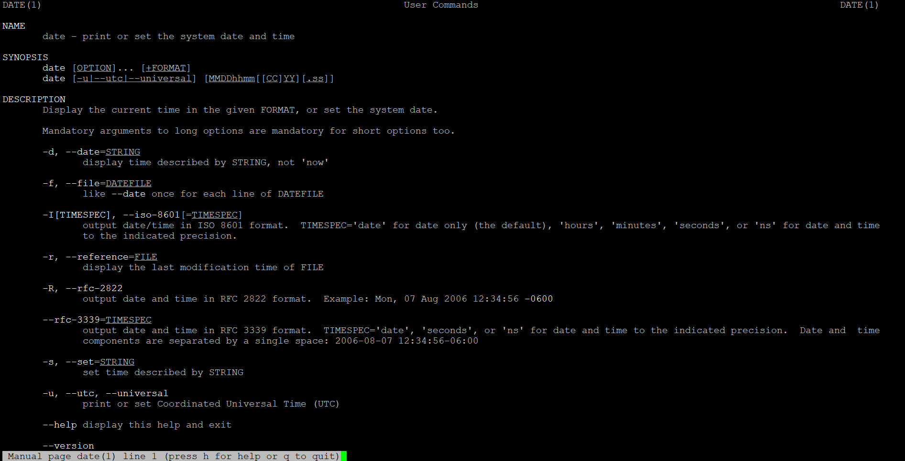

2 ls

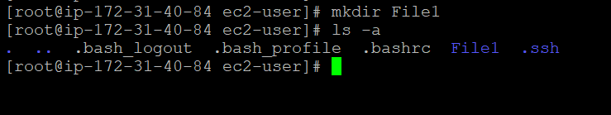

3 . List the contents of a directory and their attributes

Ls -l command used for list the file.

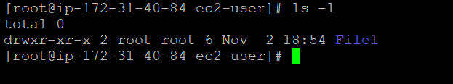

4.

Cd is used for change directory,

Touch is used for create new file,

Cat> filename is used for edit the file.

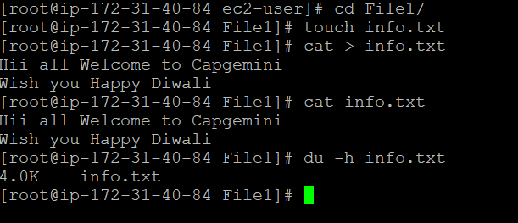

5 .

Show all files and folders including hidden one.

Ls -a shows the hidden file.

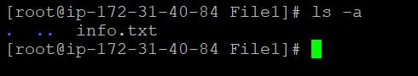

6 . list directories recursively

Ls -R command used for listing directory recursively.

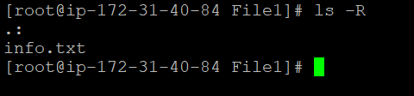

7

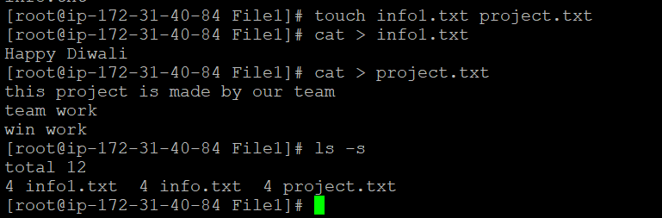

8

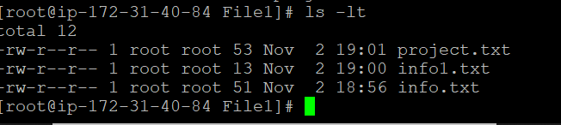

9

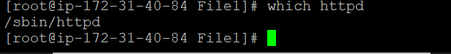

10 . cd .. command is used for switch the directory .

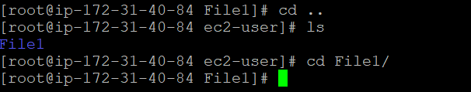

11

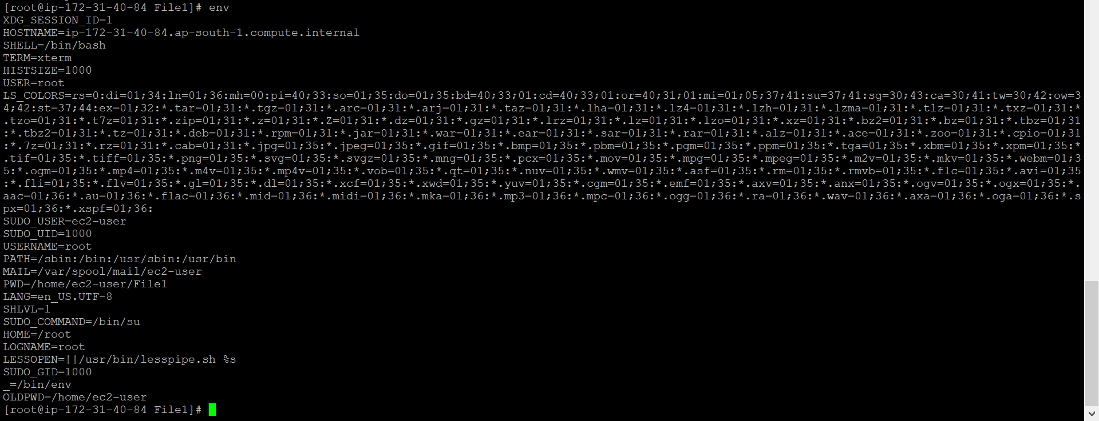

13

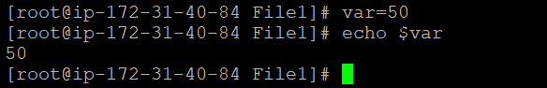

14.

Print the value of the env variable "PATH" on the console

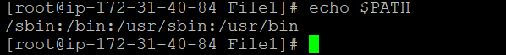

16. Display your currently logged in user



17. how do you change the currrently logged in user to another user?



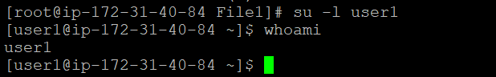

23-27

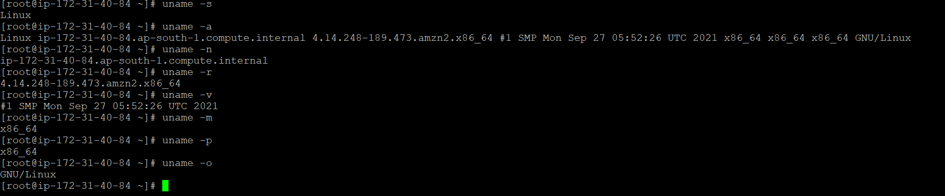

28

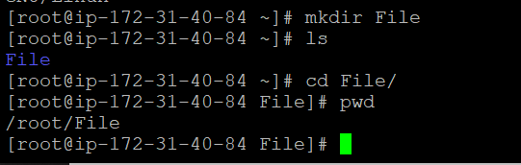

29-32

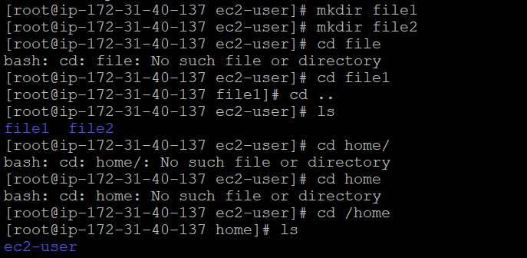

33

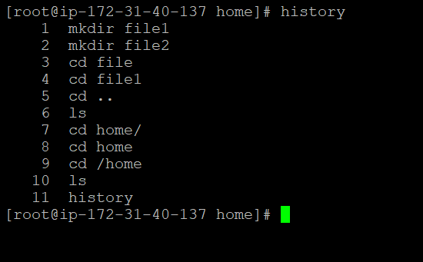

42

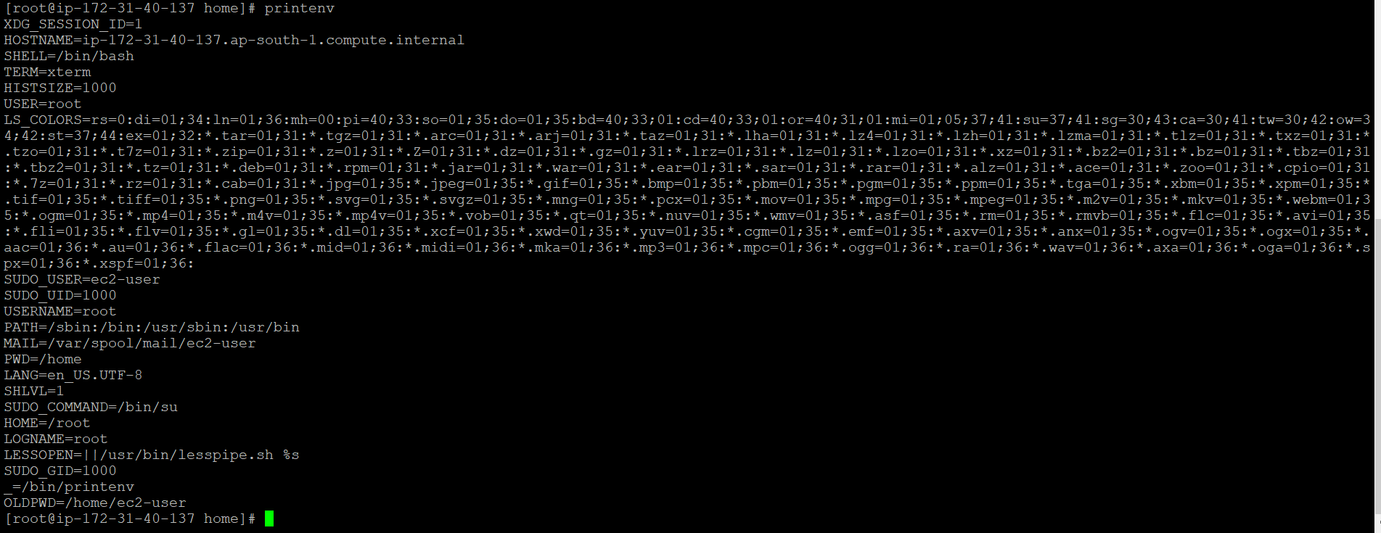

43

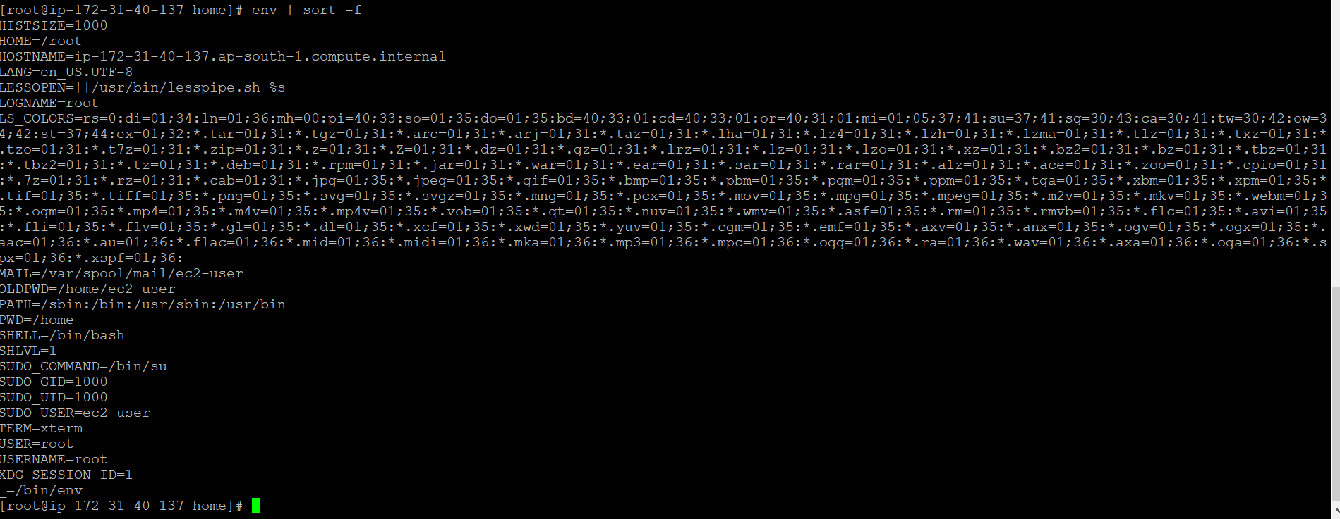

65 66

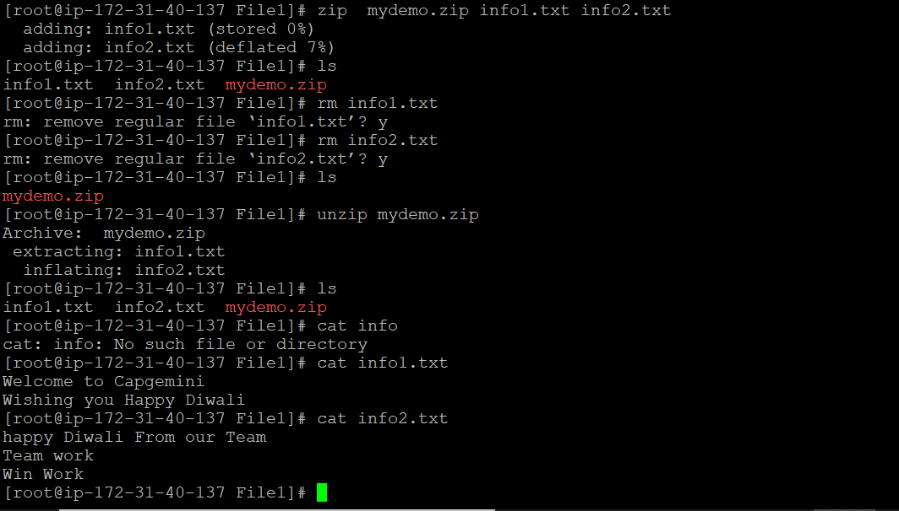

THEORY QUESTIONS-

Q. What is the diff between log-in and non log in shell.

Ans. It is an important layer of linux architecture .

. shell is an interface which takes I/P from users and sends instructions to the kernel.

. Also takes the o/p from kernel qand send the result back to output shell.

Q. What happens when you start a login shell which files are read and used and why?

Ans. It first read and execute command from the file/etc/profice, it looks for ~/. Bash- profile.

Q. Explain absolute and Relative Paths.

Ans. Absolute path:- It is defined as specifying the location of a file or directory from the root directory. (/)

. Absolute path is complete path from start of actual file system from directory.

. Relative Path :- It is defined as a path related to the present working directory .It starts at your current directory and new starts with a/.

